CSS 430 – Assignment 1

Robert Boyer

**Part 1) processes.cpp**

The figure below is my overall data flow diagram for this part of the assignment. The flow of input starts from the left side starting with *bash*as our **parent** process. From this point it will *fork and wait* to its **child** process *wc -l*, and this cycle of *forking and waiting* will repeat to the **grandchild** *grep argv[1]* and **great-grandchild** *ps –A*. Starting with the great-grandchild, it will *execute* and *output* will be directed using the different the *pipes* and *dup2* system calls to communicate all the way back to the parent process.



**Part 2) Shell.java**

Here is a summarization of what the fuction ***run()*** does at a high level.

**While(){**

**Prompt user;**

**Read input from terminal (convert to string);**

**Check if command is to exit/stop (If so stop, else continue)**

**Split string input by ‘;’ and store into array 1**

**For(){**

**Split each string in array 1 by ‘&’ and store result in array 2**

**For(){**

**Converts strings in array 2 to arguments to be stored in array 3**

**Starts child thread**

**Outputs thread id**

**}**

**For(){**

**Wait for termination of child thread(s), returns it’s thread id**

**}**

**}**

**}**

**Part 1)**

Tests done:

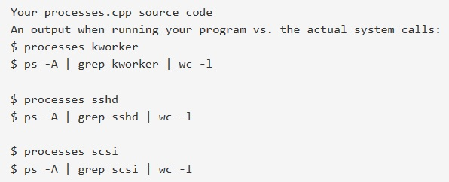

Results of tests:

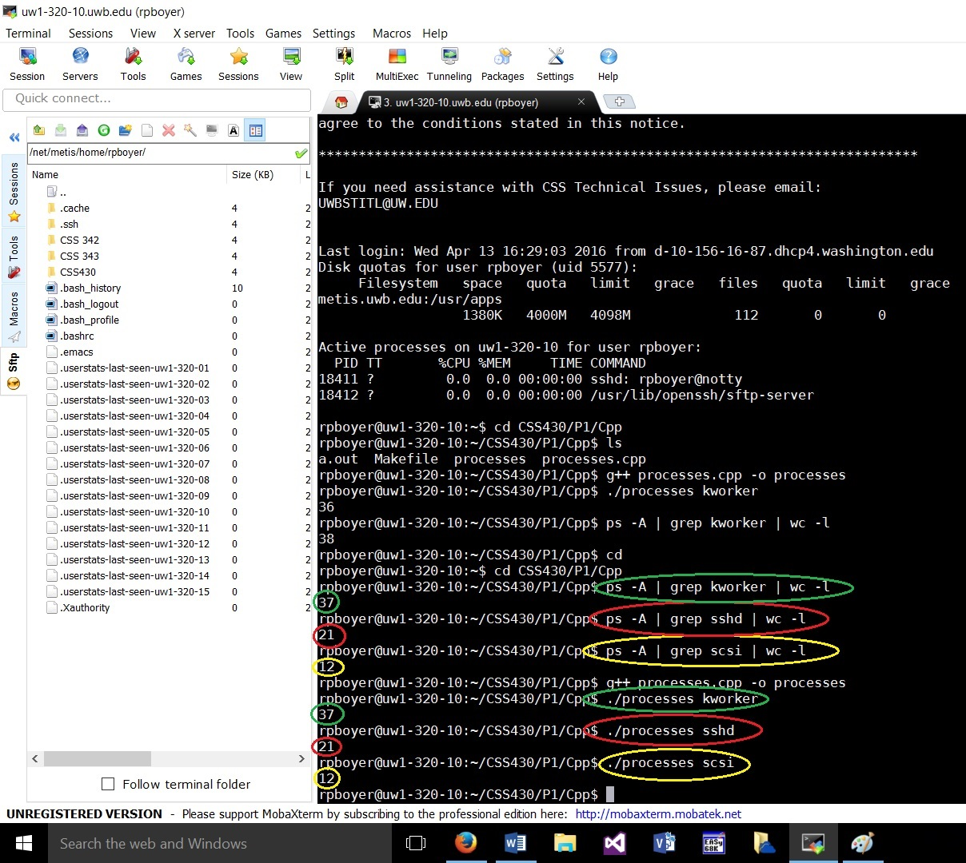

**Part 2)**

Stress test done:

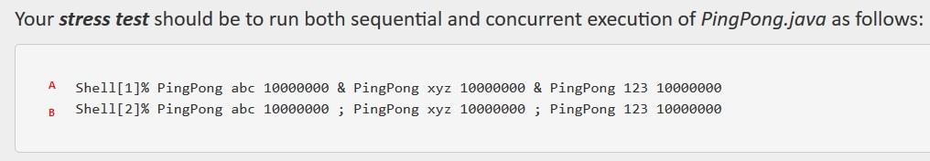

Results of test:

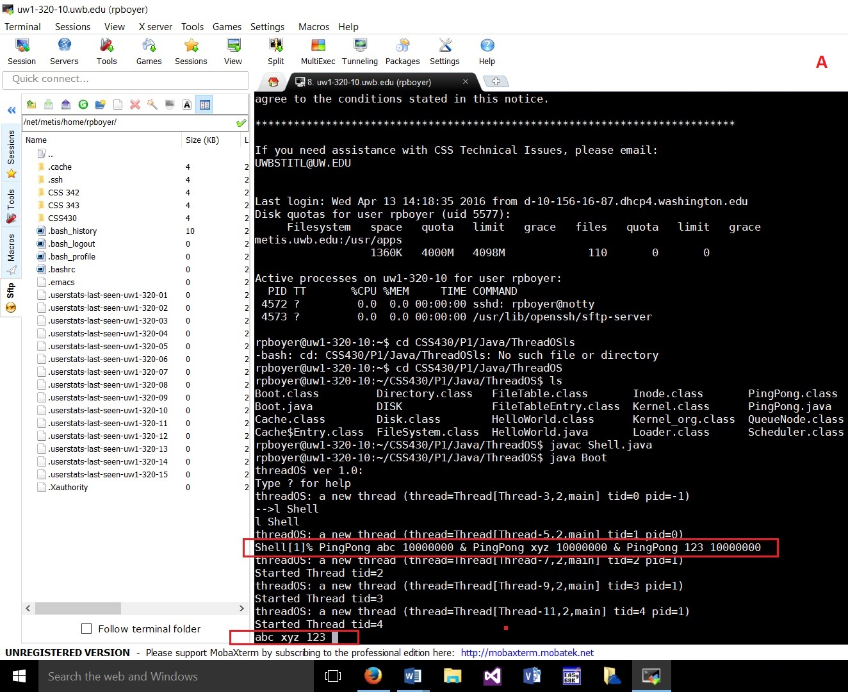

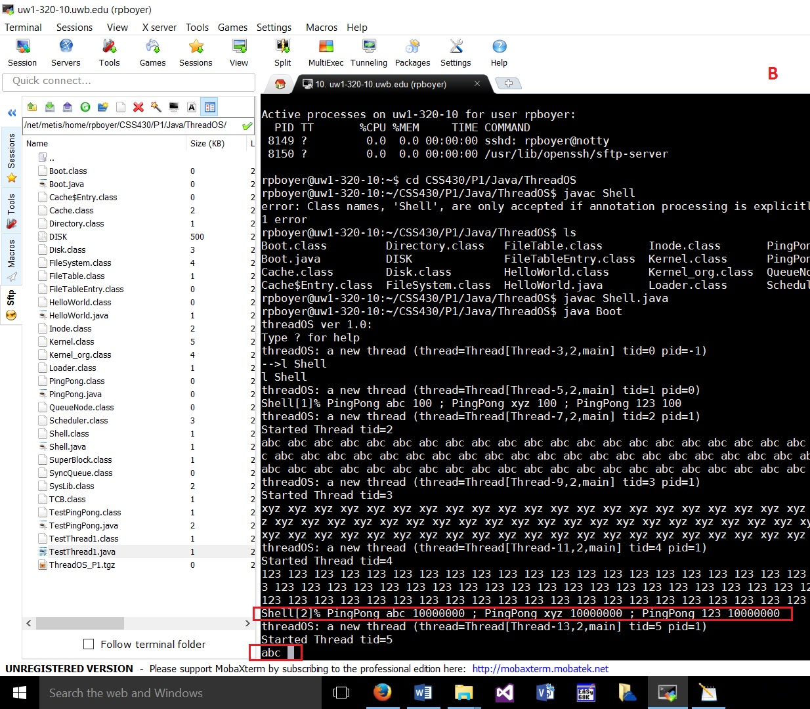

Normal test cases done:

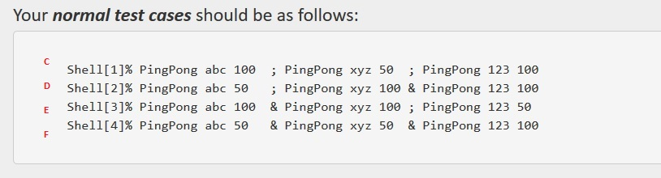

Results of test:

